# 1 INTRODUCTION

* + Overview

Radisson Hospitality AB (Radisson) is one of the leading hotel companies in Europe, the Middle East, and Africa. It operates leases, manages, and franchises hotels in 78 countries across Europe, the Middle East, and Africa. The company operated 1,700 hotels and 2,60,000 rooms in operation and 125 hotels and 24,985 rooms are under development across Europe, the Middle East, and Africa. Radisson's hotels are operated by themselves or through lease, management agreement, or franchise agreement under its brands. Its portfolio comprises well-segmented hotel brands, including Radisson Blu, Park Inn by Radisson, Radisson Red, Radisson, Park Plaza, and Country Inn and suites

1.2Purpose

A company founded by Curtis L. Carlson in 1938 was formally known as Carlson Companies Inc. in 1962; Curt Carlson purchased the nationally known Radisson Hotel in Minneapolis, USA. The company is comprised of four different groups known as Carlson Wagonlit, Carlson Hospitality Worldwide, Carlson Marketing Group and Carlson Leisure Group. The basic formula of running a hotel chain was based on “growth at any cost” and they were opening hotels at about 1 hotel in 7 days.

# problem definition & design thinking

2.1Empathy Map

# 

2.2 Identification & Brainstroming map screenshot

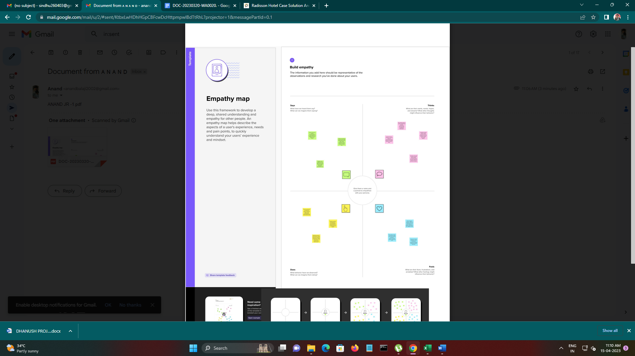

# Result

|  |  |  |
| --- | --- | --- |
| |  | | --- | | Dashboard | |  |

<https://public.tableau.com/app/profile/anand.j.r/viz/anandjr4/RADISSONHOSPITALLITYANALYSIS?publish=yes>

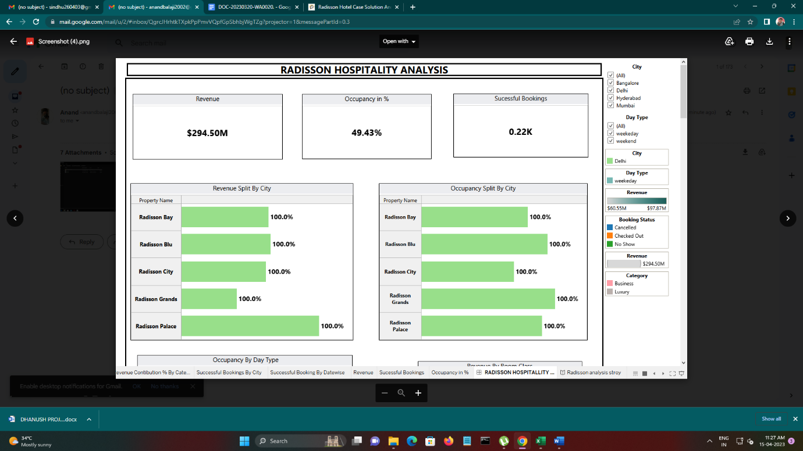

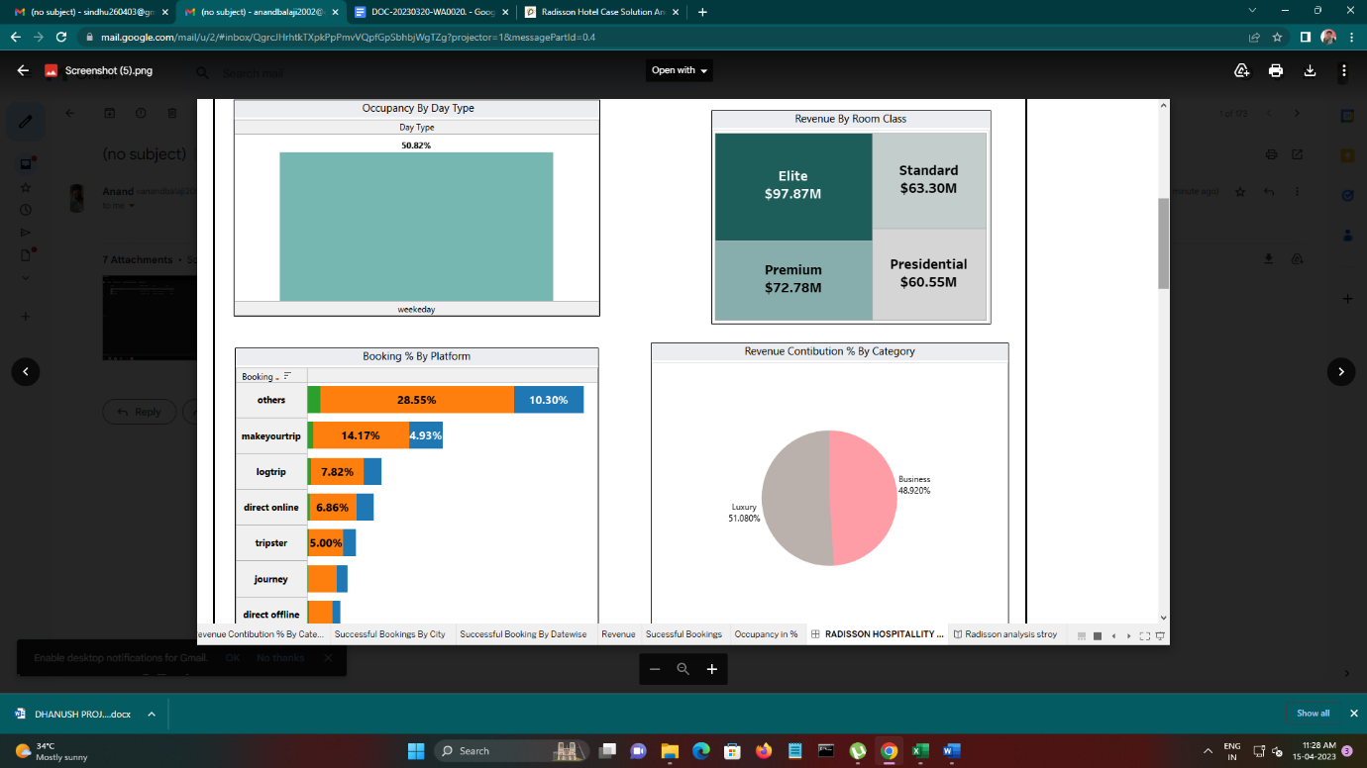

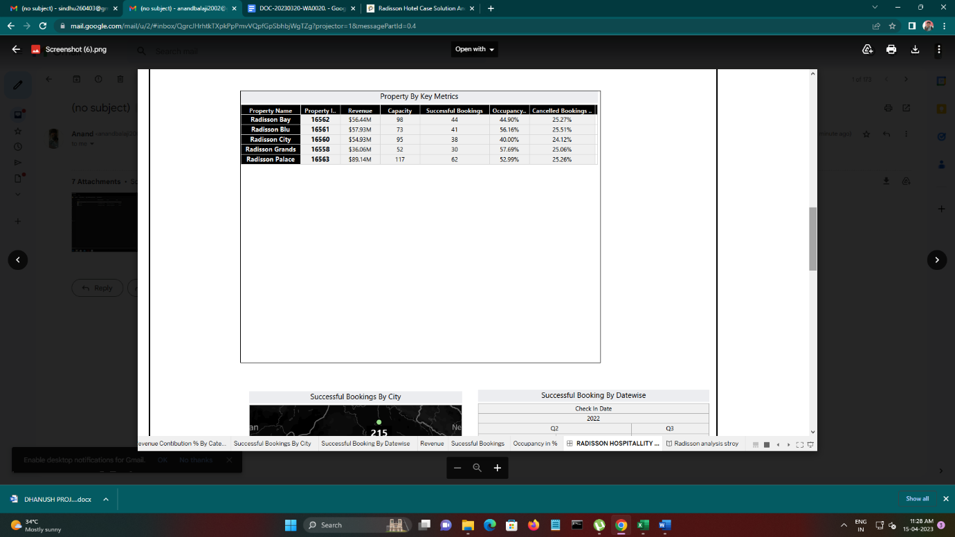

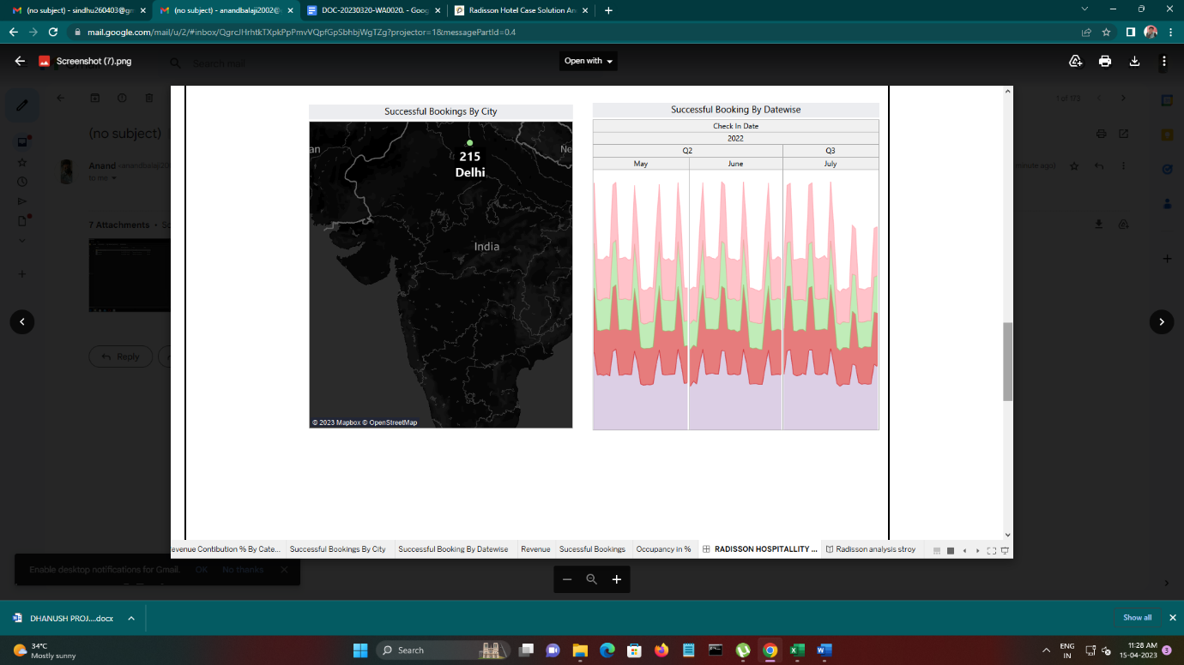

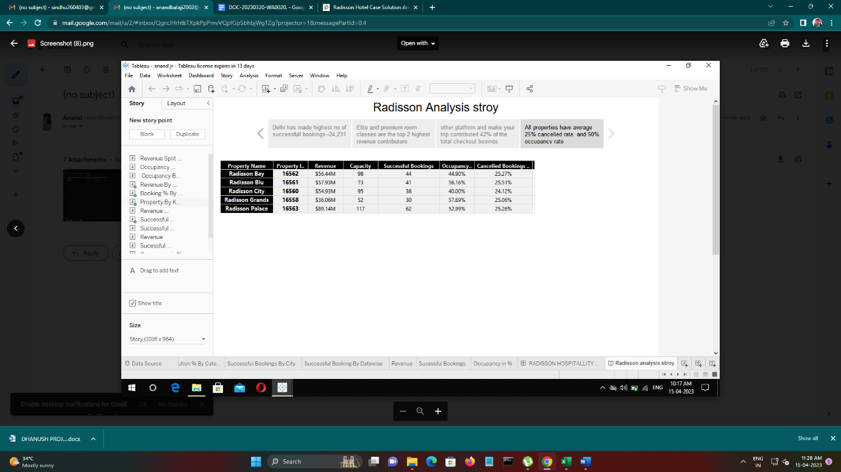

# Advantages & Disadvantages

* As a result of growth at any cost strategy, the focus of the hotel was diverted from customers to growth strategy
* In addition to that, the company started facing challenges of low employee satisfaction and service in-consistencies.
* The company got into deep trouble because the management was not proceeding in a clear direction. Furthermore, the company was not focused on building a brand image to build customer loyalty.
* After analyzing the whole situation, the President and Vice President of the company realized an urgent need for designing operational strategies to make it more customer-centric.
* After abroading the whole situation, the President and Vice President of the company realized an urgent need for designing operational strategies to make it more customer-centric.
* In addition to that, the company started facing challenges of low employee satisfaction and service in-consistencies.
* The company got into deep trouble because the management was finished.

# 5 Application

 Radisson executed a technique named as "complaint card" that was utilized to gather visitor criticism at the end of their stay in the hotel.  This project was unsuccessful because numerous visitors did not even finish them; as a result the organization was required to take some different measures. Radisson could enhance the experience of customers by giving membership benefits and discount programs. Customers who visited on a continuous basis may get a steeper discount than consistent inn rates.  Guests who fill out the card completely or take a review over the Internet may get a ten percent rebate off their following visit.  Customer recognition is a vital idea, particularly in an industry that characterizes their services as an "experience."  By improving their services for customers with completely coordinated information frameworks, they provide astounding solid and reliable services.  With these set-up measures, satisfaction of employees and customers remain predictable and continue to progress constantly.

Management of Radisson also applied IT techniques to incorporate the information related to their guests backed by marketing infrastructure. The main focus of the hotel became the training of employees to create a network that could be globally accessed by all the Radisson Hotels globally. This helped the company to build a uniform database structure all over the world. The primary motive behind these designs was to ensure reliable and consistent relationships with all guests and customers of Radisson Hotels. With the help of new systems, the hotel management would be able to plan better marketing strategies to attract customers. Along with that, it will help the company to build strong and long-term relationship with its guests by providing facilities that they do not get anywhere else.

With the help of internet technology, the guest may check-in in the hotel from anywhere including airports, from their laptops or cell phones, etc. Advance check-in will help the business to make advance preparations for guests.

# Conclusion

According to many researches done by scholars, it has been identified that good and satisfactory service provided by employees will lead to customer satisfaction. In addition to that, it has been observed that when an employee is satisfied with the [management](https://www.thecasesolutions.com/sapient-corp-10358) of the company, they finally give better services to customers and good customer service is the essence of the Hotel Industry. Loyalty with customers is also linked with the performance of employees. If an employee is greeting well, this customers will increase customer loyalty towards the brand. Satisfaction of employees had an impact on employees’ perception about the company.

Making improvements involve working together.

# Future scope

Making improvements involve working together [measuring employee](https://www.thecasesolutions.com/will-racingtheplanet-ltd-reach-the-finish-line-7718) and customer satisfaction. To increase customer satisfaction, the management of Radisson Hotels needs to focus on the satisfaction of employees. To do so, the management needs to implement several programs that will ensure the satisfaction of employees so that efficiency and performance of the organization can be enhanced. The efficiency and performance will increase that will reinforce customer service. The management of the company needs to understand that employee should better understand the Radisson’s vision and mission to be aligned with the firm. Radisson can do that by motivating its employees through Rewards and Incentives which in turn will present a chance for advancement..........

This is just a sample partial case solution. Please place the order on the website to order your own originally done case solution.

# Appendix

A . Source Code